**NAME: BINYANYA DEBORAH NYATICHI**

**CS NO: ADC-CSS02-25051**.

**DESCRIPTION: Week 2 Assignment 3**

**ASSIGNMENT: Lab on Microsoft Identity and Access Management Solutions**

**DATE: 05/04/2025**

INTRODUCTION

In today's digital landscape, robust identity management is paramount for security, compliance, and user productivity. This lab series is designed to provide you with hands-on experience in key components of Microsoft's cutting-edge IAM platform, Microsoft Entra ID (formerly Azure AD).mThrough a series of focused labs, you will delve into critical functionalities that empower organizations to manage user identities, secure access to resources, and streamline administrative tasks. We will move beyond theoretical concepts and provide practical scenarios where you can configure and observe these powerful features in action.

This lab will guide you through the following essential areas:

* **Explore Microsoft Entra ID User Settings:** Gain a foundational understanding of how user accounts are managed within Microsoft Entra ID, including profile settings, contact information, and organizational relationships.
* **Microsoft Entra self-service password reset (SSPR):** Discover how to empower users to securely reset their own passwords, reducing helpdesk burden and improving user convenience.
* **Microsoft Entra Conditional Access:** Learn how to implement granular access control policies based on various conditions, such as user location, device compliance, and application sensitivity, to enhance security.
* **Explore Privileged Identity Management (PIM):** Understand how to manage, control, and monitor access to important resources within your organization by implementing just-in-time and approval-based privileged access.

# Lab: Microsoft Entra Conditional Access

This lab maps to the following Learn content:

* Learning Path: Describe the capabilities of Microsoft Entra
* Module: Describe access management capabilities of Microsoft Entra
* Unit: Describe Conditional Access

# Lab scenario

In this lab, you'll explore conditional access MFA, from the perspective of an admin and a user. As the admin, you will create a policy that will require a user to go through multi-factor authentication when accessing any of the Microsoft Admin portals. From a user perspective, you'll see the impact of the conditional access policy, including the process to register for MFA.

## Task 1

In this task you, as the admin, will reset the password for the user Debra Berger. This step is needed so you can initially sign in as the user in subsequent tasks.

Open Microsoft Edge. In the address bar, enter https://entra.microsoft.com, and sign in with your admin credentials.

In the Sign-in window, enter admin@WWLx730857.onmicrosoft.com (where ZZZZZZ is your unique tenant ID provided by your lab hosting provider) then select Next.

Enter the admin password that should be provided by your lab hosting provider. Select Sign in.

Depending on your lab hoster and if this is the first time you are logging in to the tenant, you may be prompted to complete the MFA registration process. If so, follow the prompts on the screen to setup MFA.

Once you're signed-in, you're taken to the Microsoft 365 admin center page.

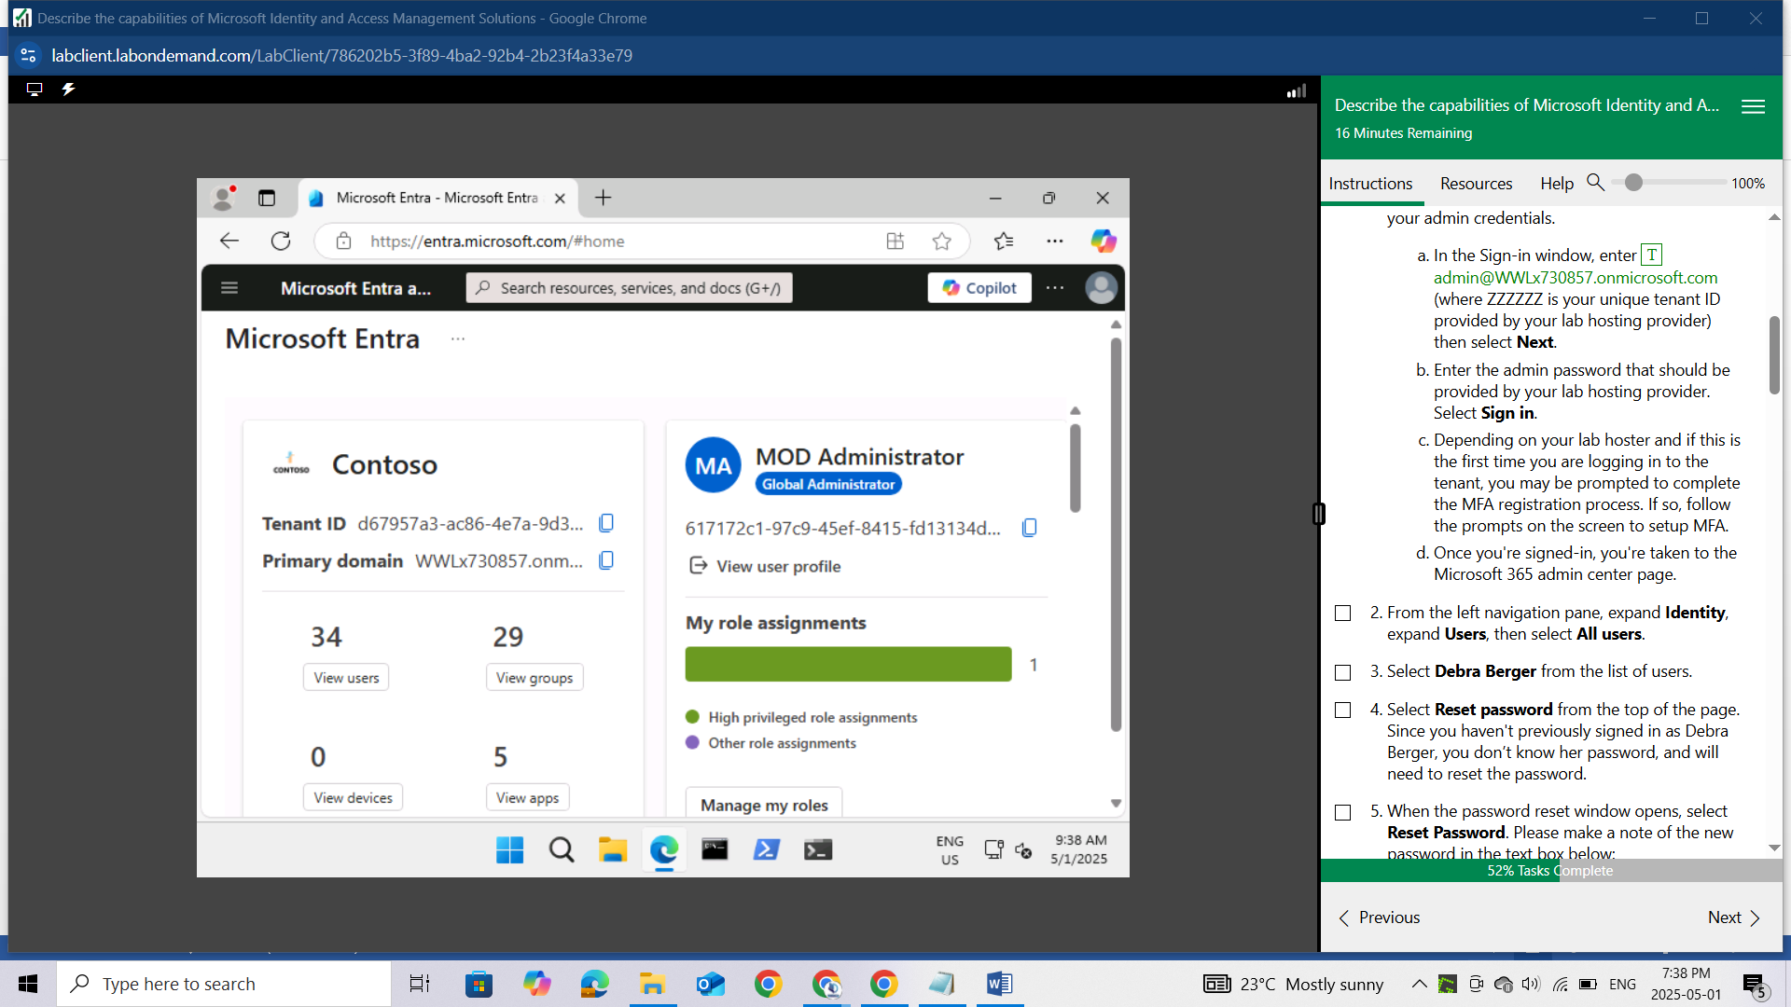

From the left navigation pane, expand Identity, expand Users, then select All users.

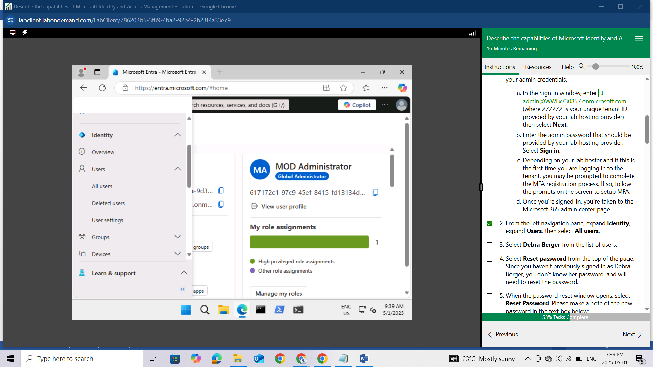

Select Debra Berger from the list of users.

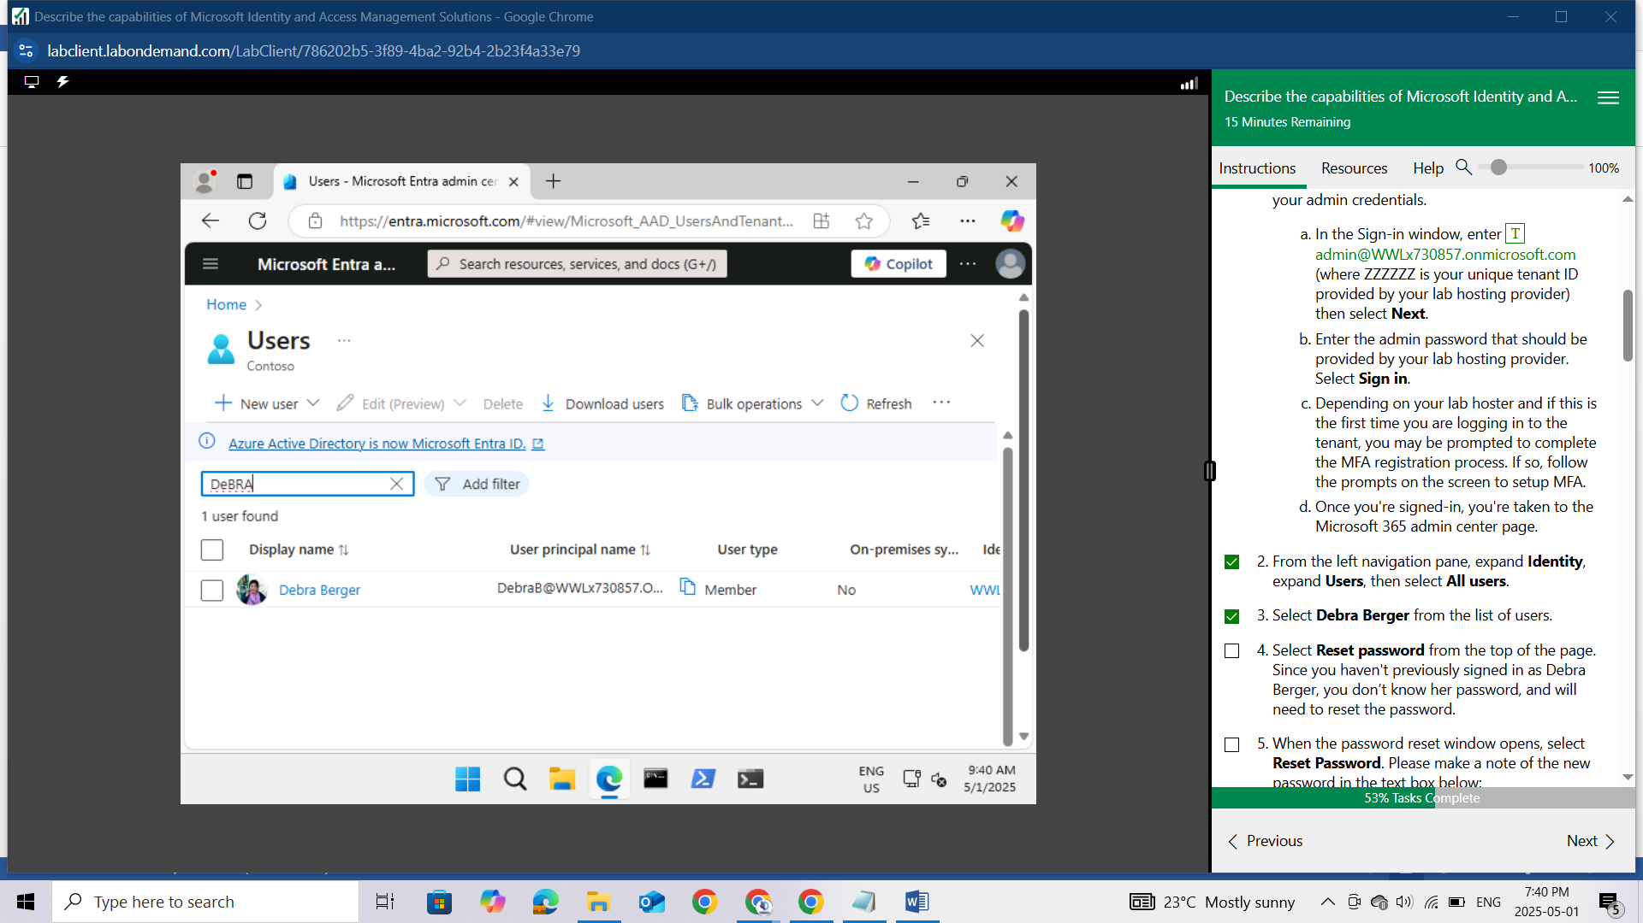

Select Reset password from the top of the page. Since you haven't previously signed in as Debra Berger, you don’t know her password, and will need to reset the password.

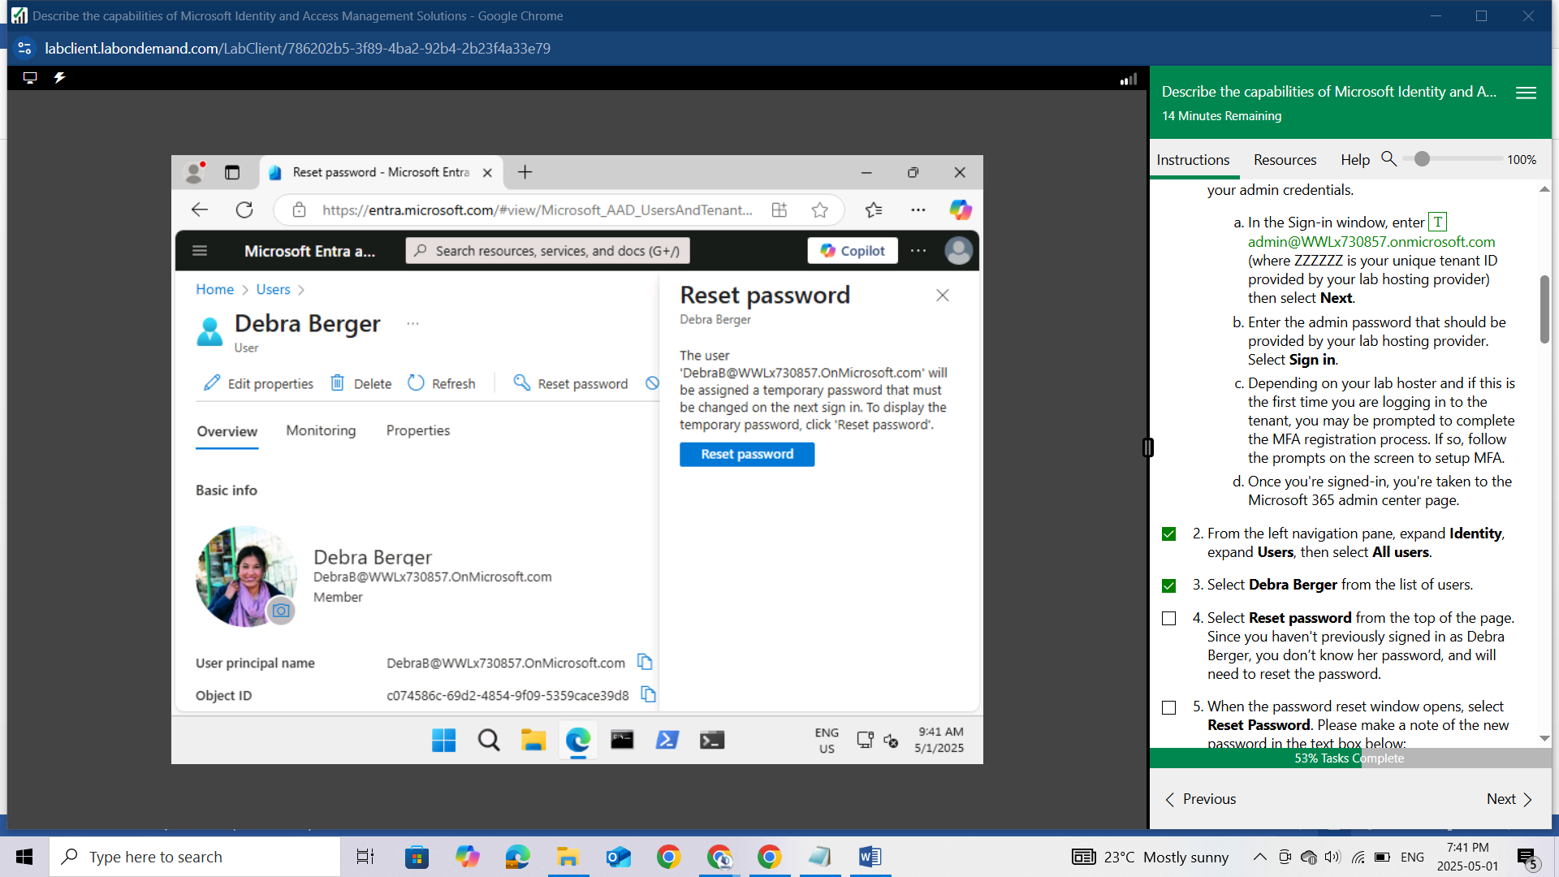

When the password reset window opens, select Reset Password. Please make a note of the new password in the text box below:

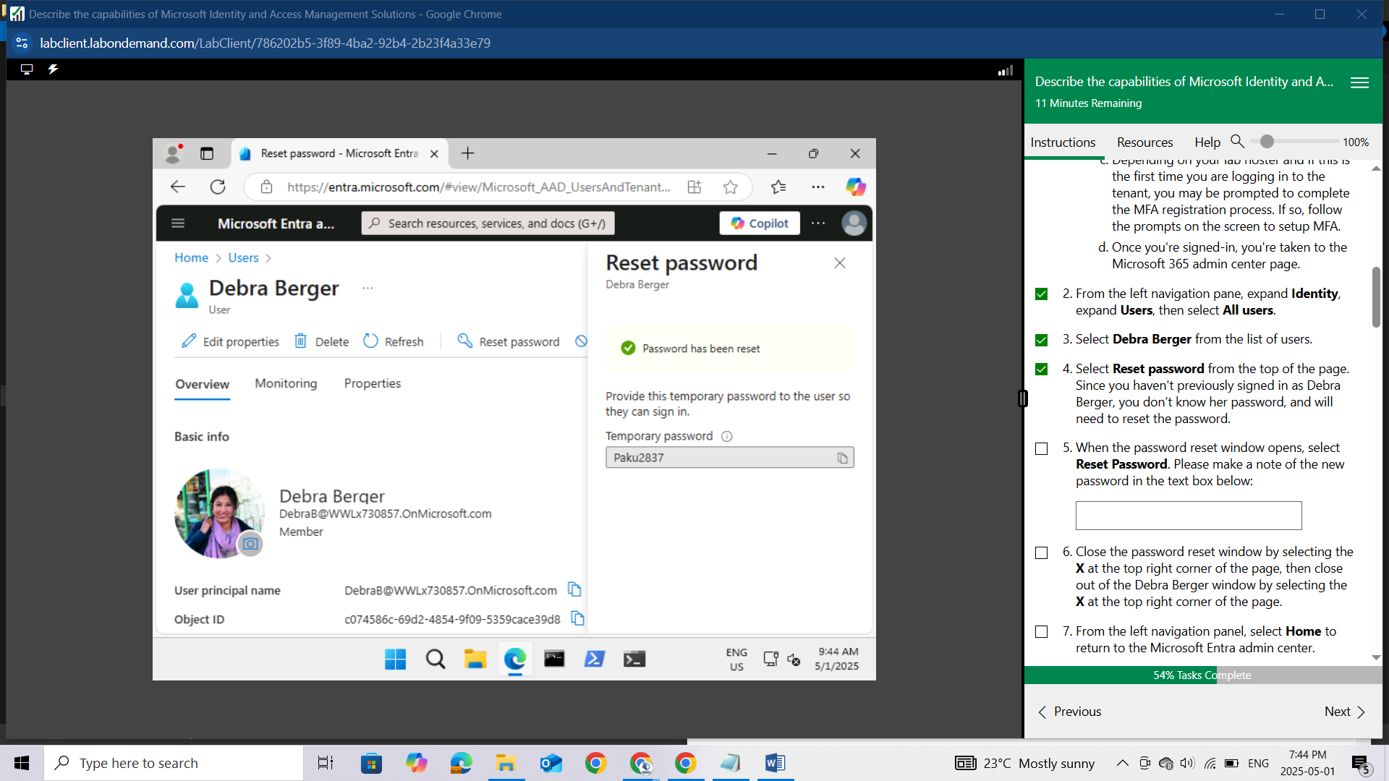

Close the password reset window by selecting the X at the top right corner of the page, then close out of the Debra Berger window by selecting the X at the top right corner of the page.

From the left navigation panel, select Home to return to the Microsoft Entra admin center.

Keep this window open.

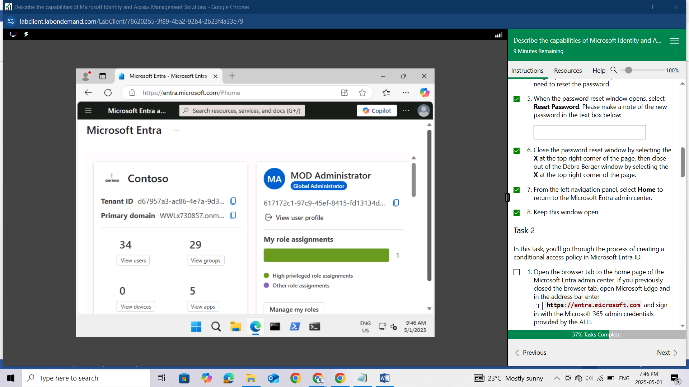

## Task 2

In this task, you'll go through the process of creating a conditional access policy in Microsoft Entra ID.

Open the browser tab to the home page of the Microsoft Entra admin center. If you previously closed the browser tab, open Microsoft Edge and in the address bar enter https://entra.microsoft.com and sign in with the Microsoft 365 admin credentials provided by the ALH.

From the left navigation pane, expand Protection then select Conditional Access.

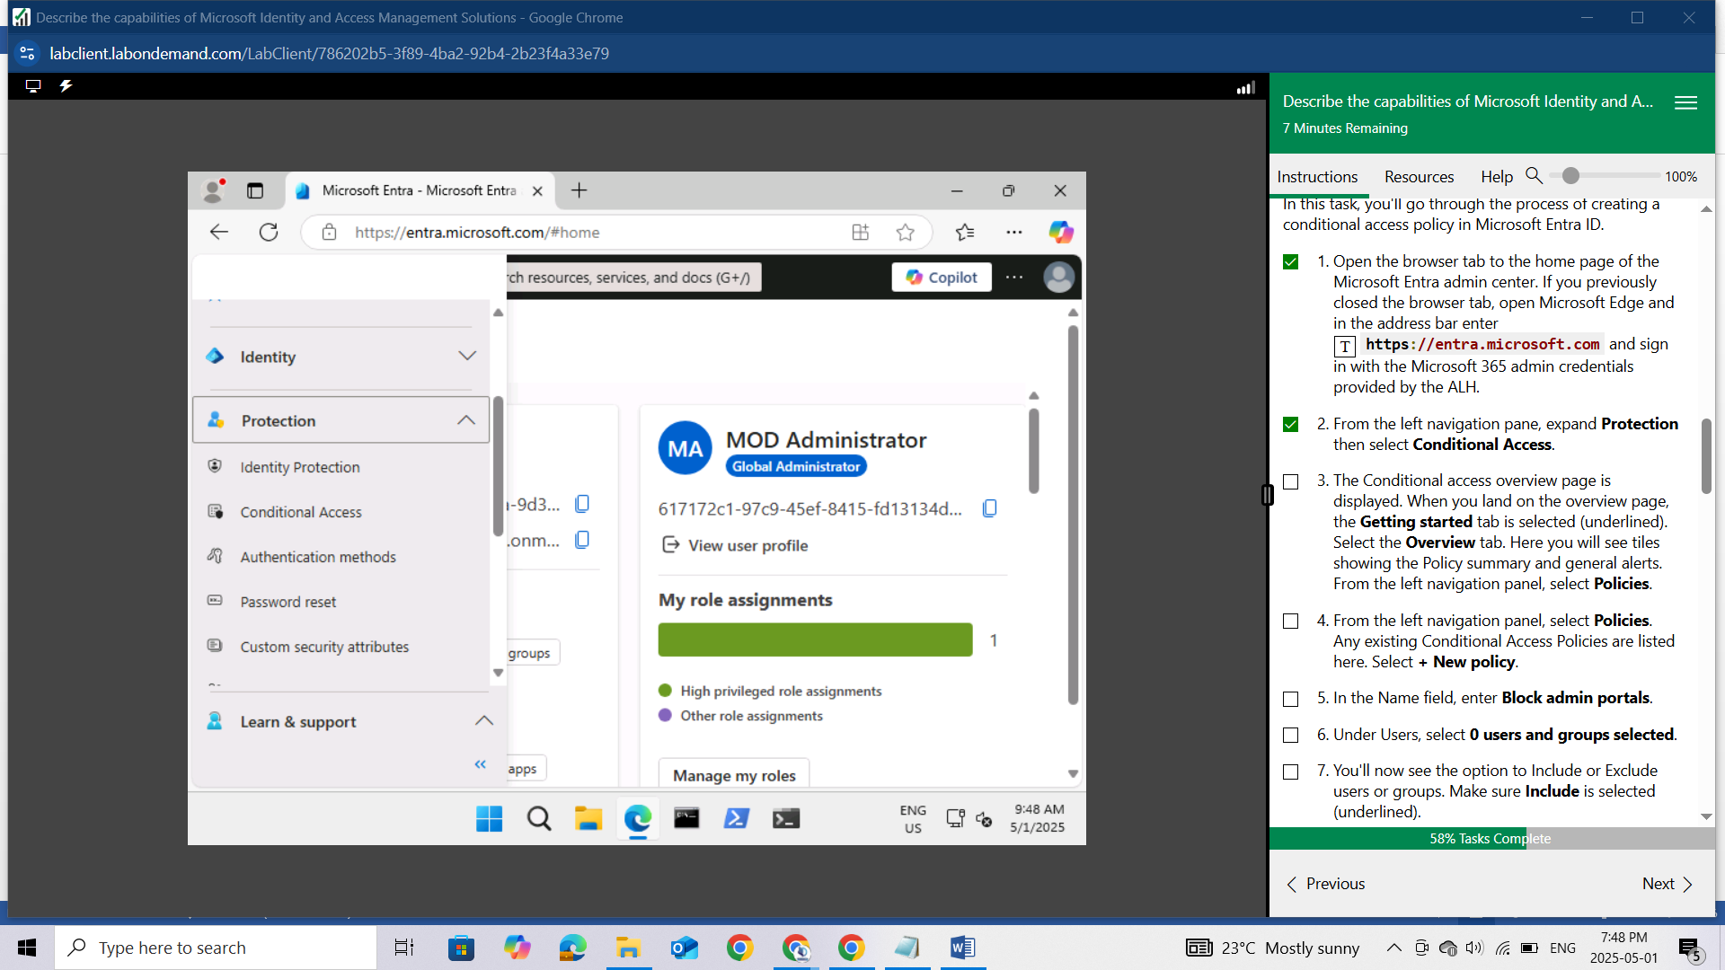

The Conditional access overview page is displayed. When you land on the overview page, the Getting started tab is selected (underlined). Select the Overview tab. Here you will see tiles showing the Policy summary and general alerts.

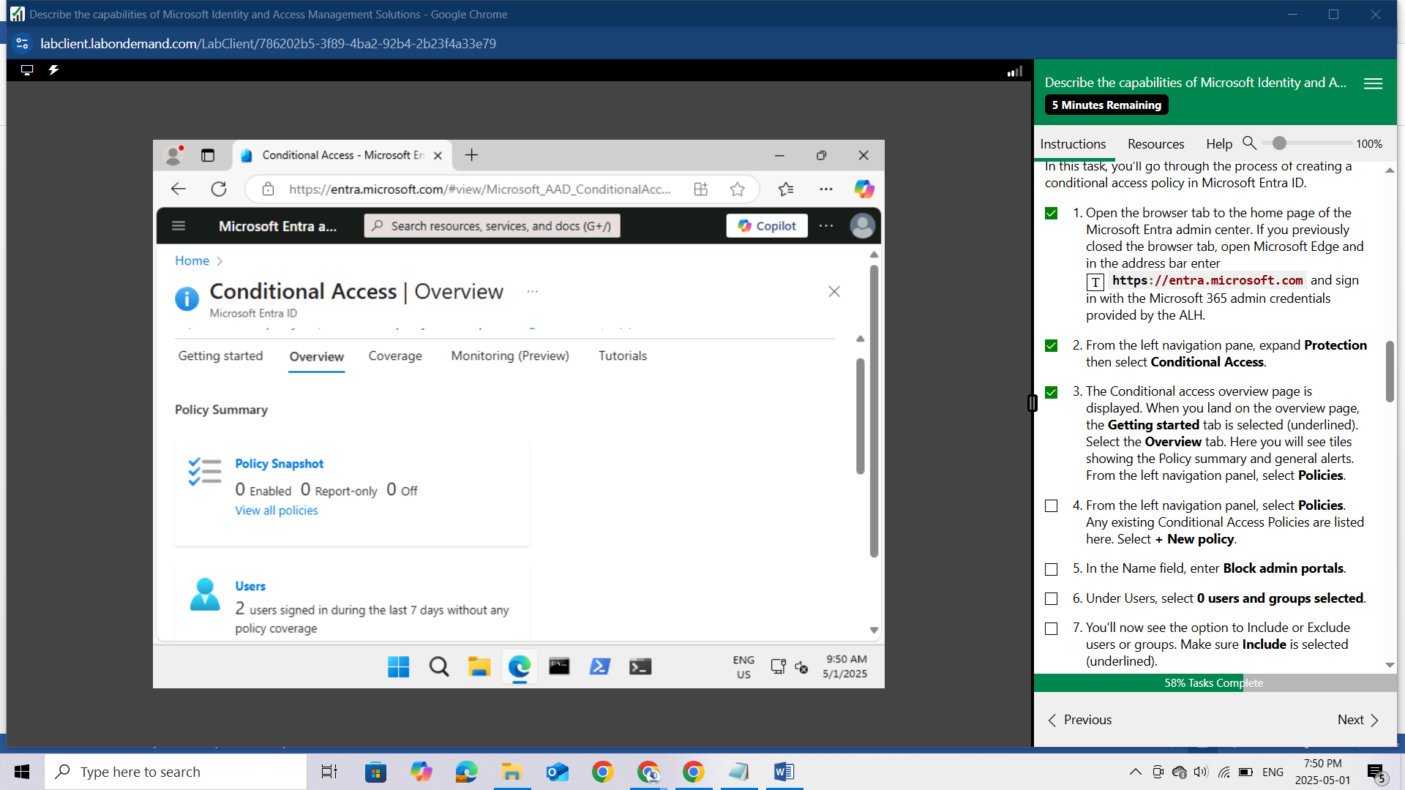

From the left navigation panel, select Policies.

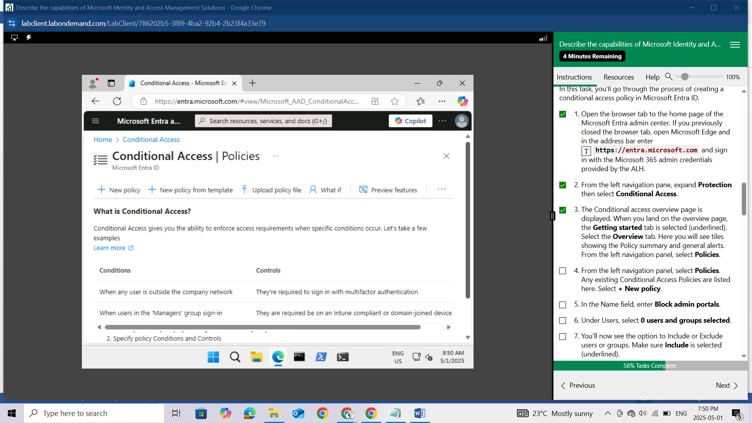

Any existing Conditional Access Policies are listed here. Select + New policy.

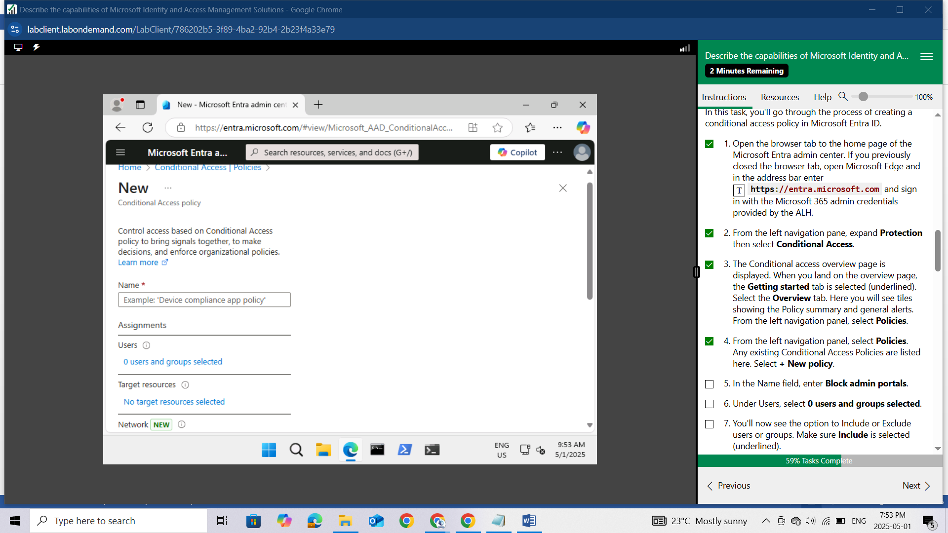

In the Name field, enter Block admin portals.

Under Users, select 0 users and groups selected.

You'll now see the option to Include or Exclude users or groups. Make sure Include is selected (underlined).

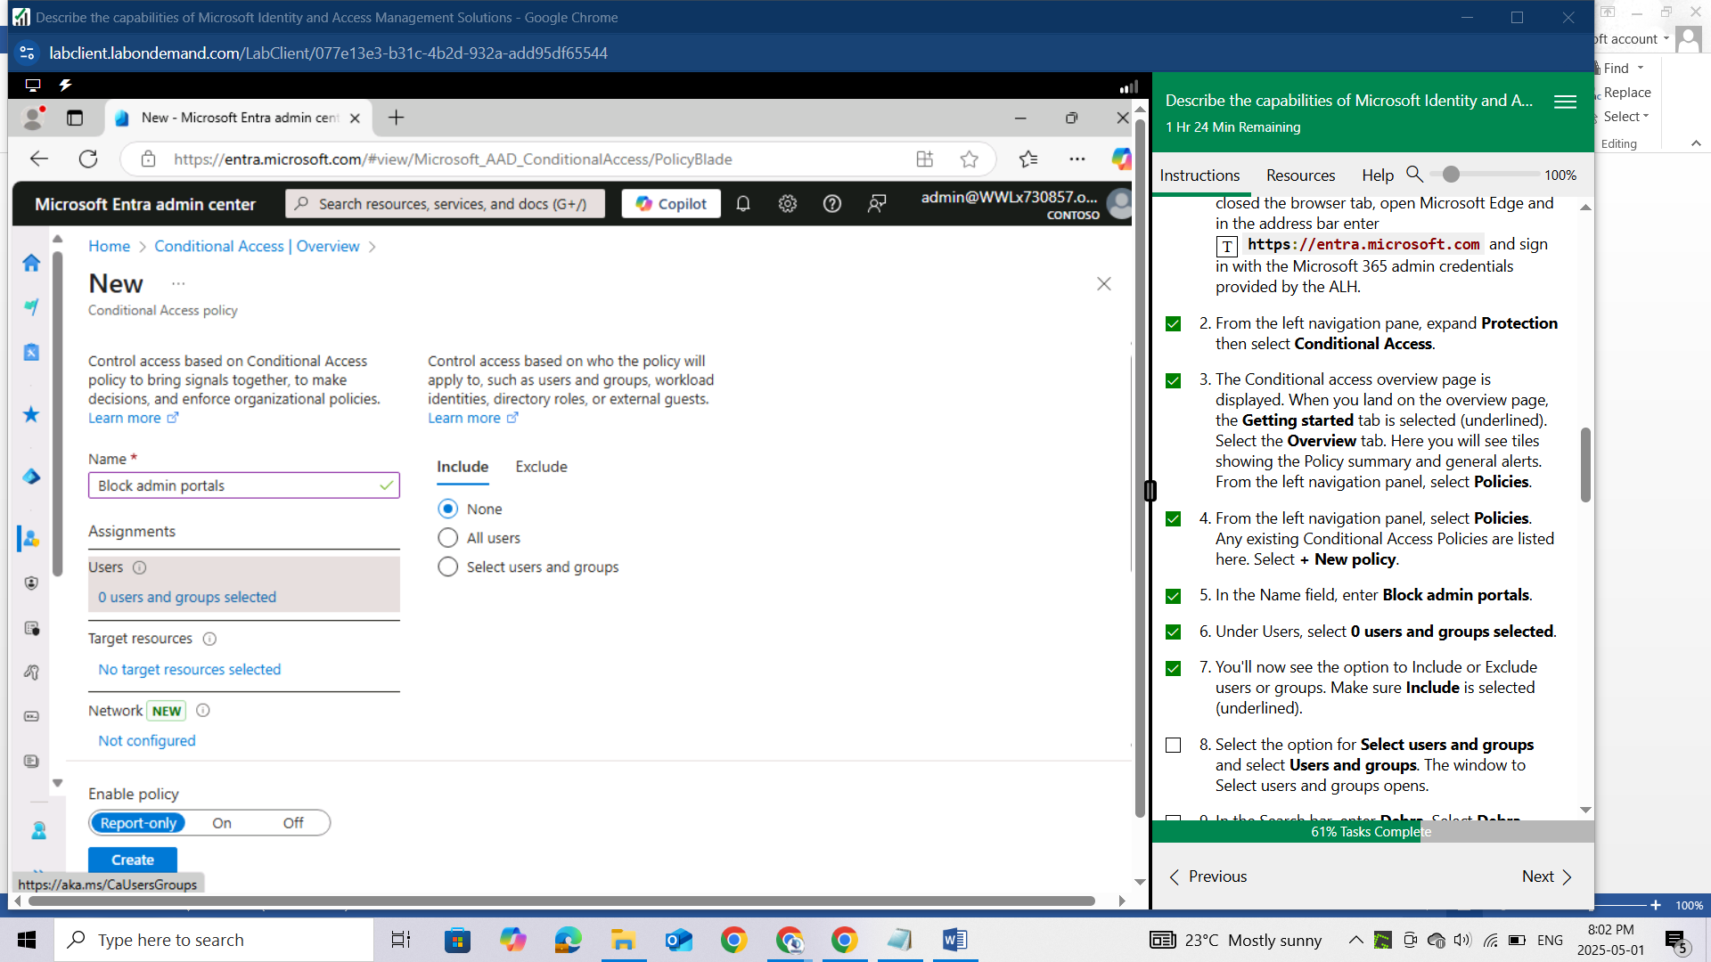

Select the option for Select users and groups and select Users and groups. The window to Select users and groups opens.

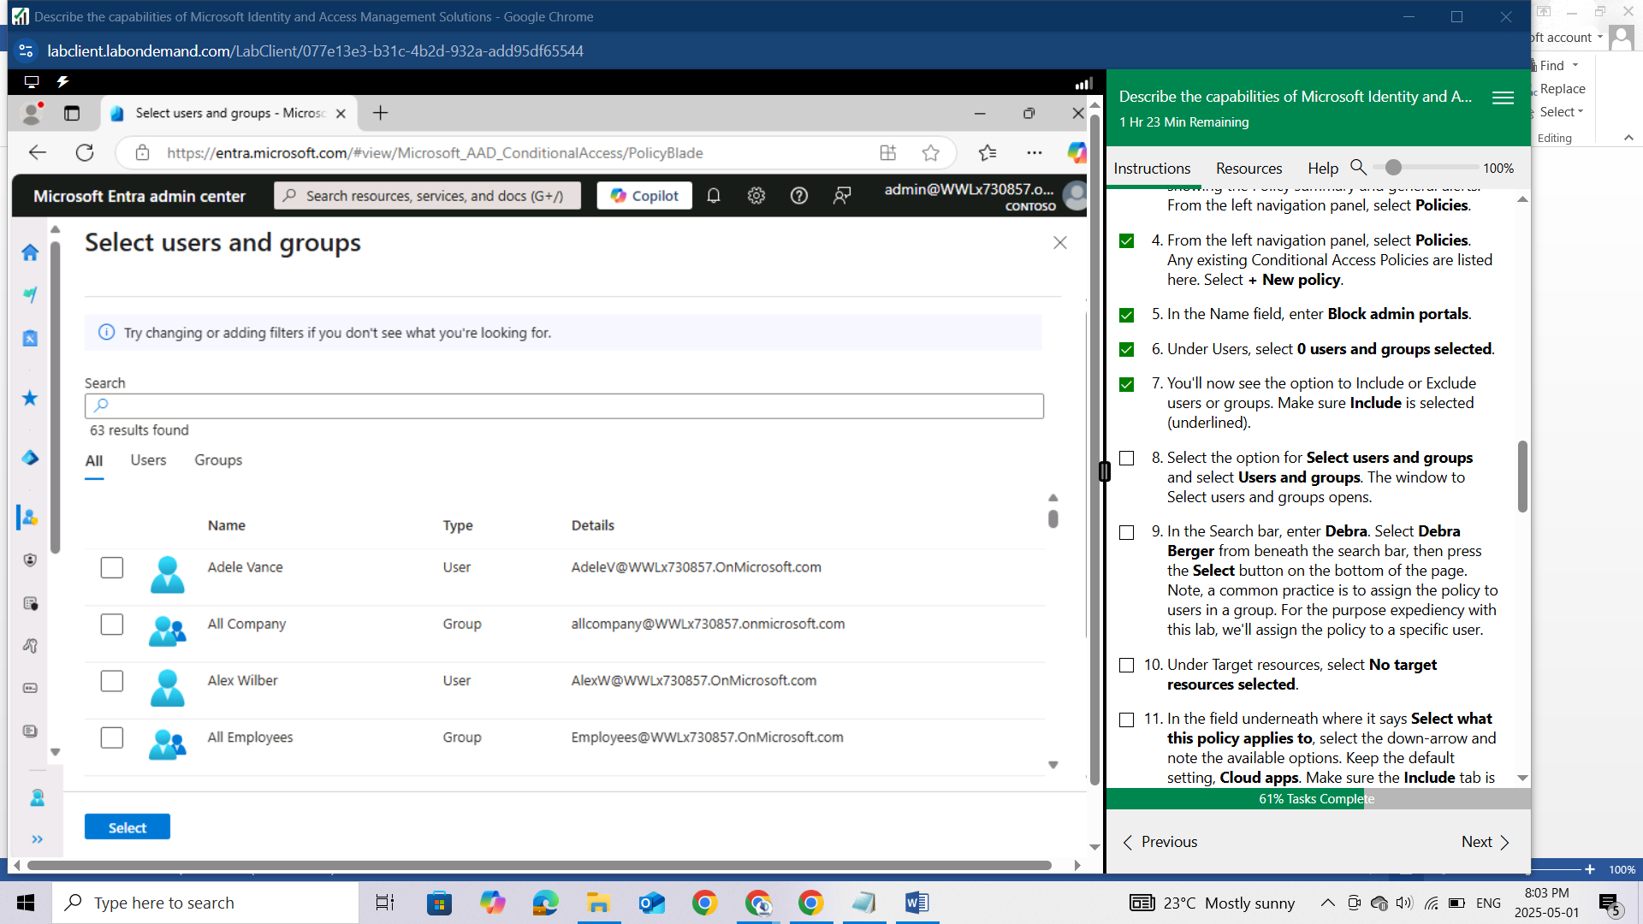In the Search bar, enter Debra. Select Debra Berger from beneath the search bar, then press the **Select** button on the bottom of the page. Note, a common practice is to assign the policy to users in a group. For the purpose expediency with this lab, we'll assign the policy to a specific user.

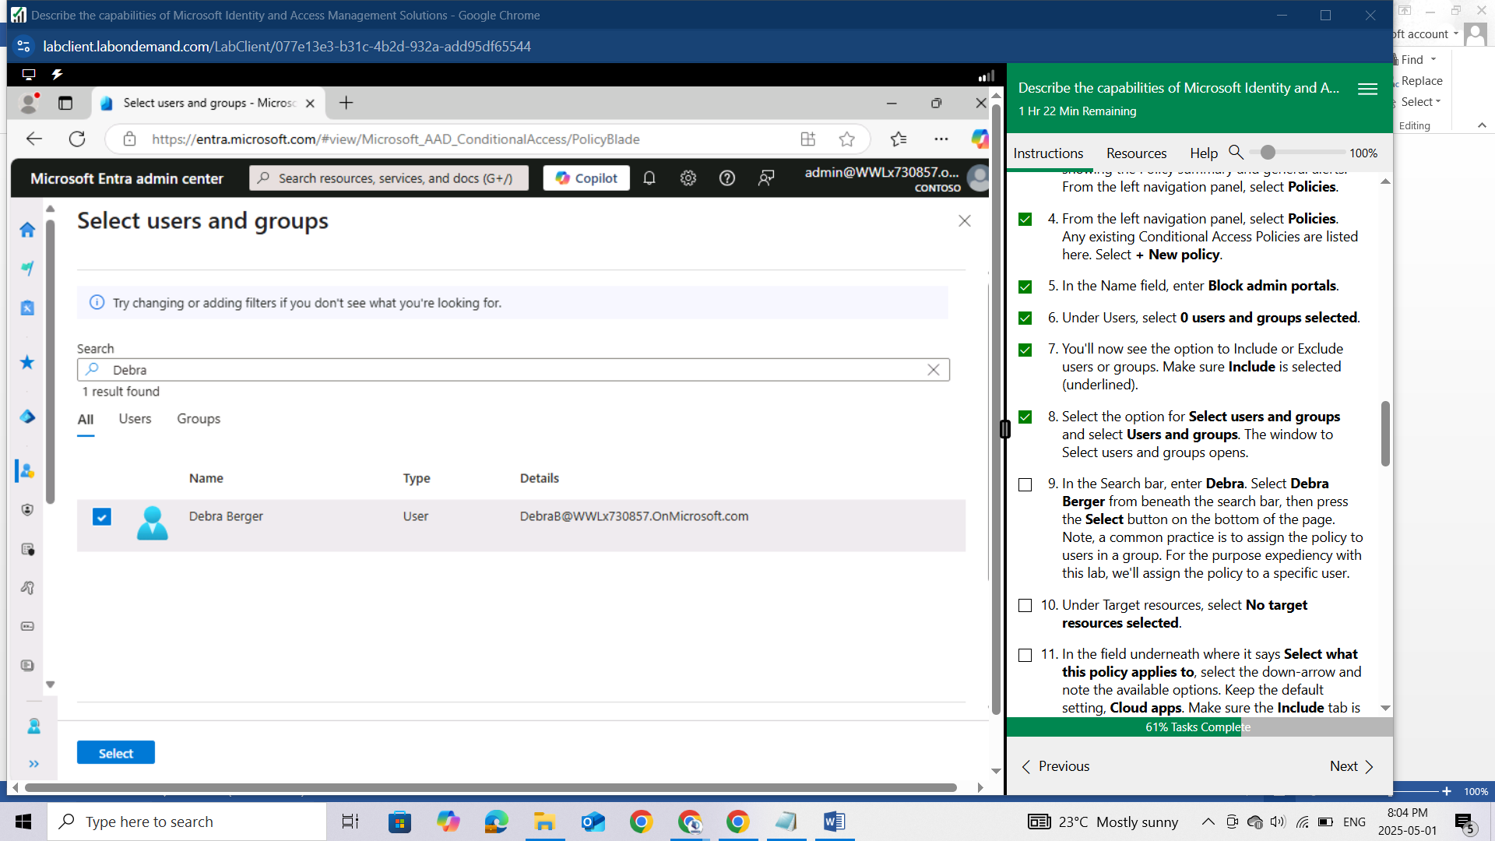

Under Target resources, select No target resources selected.

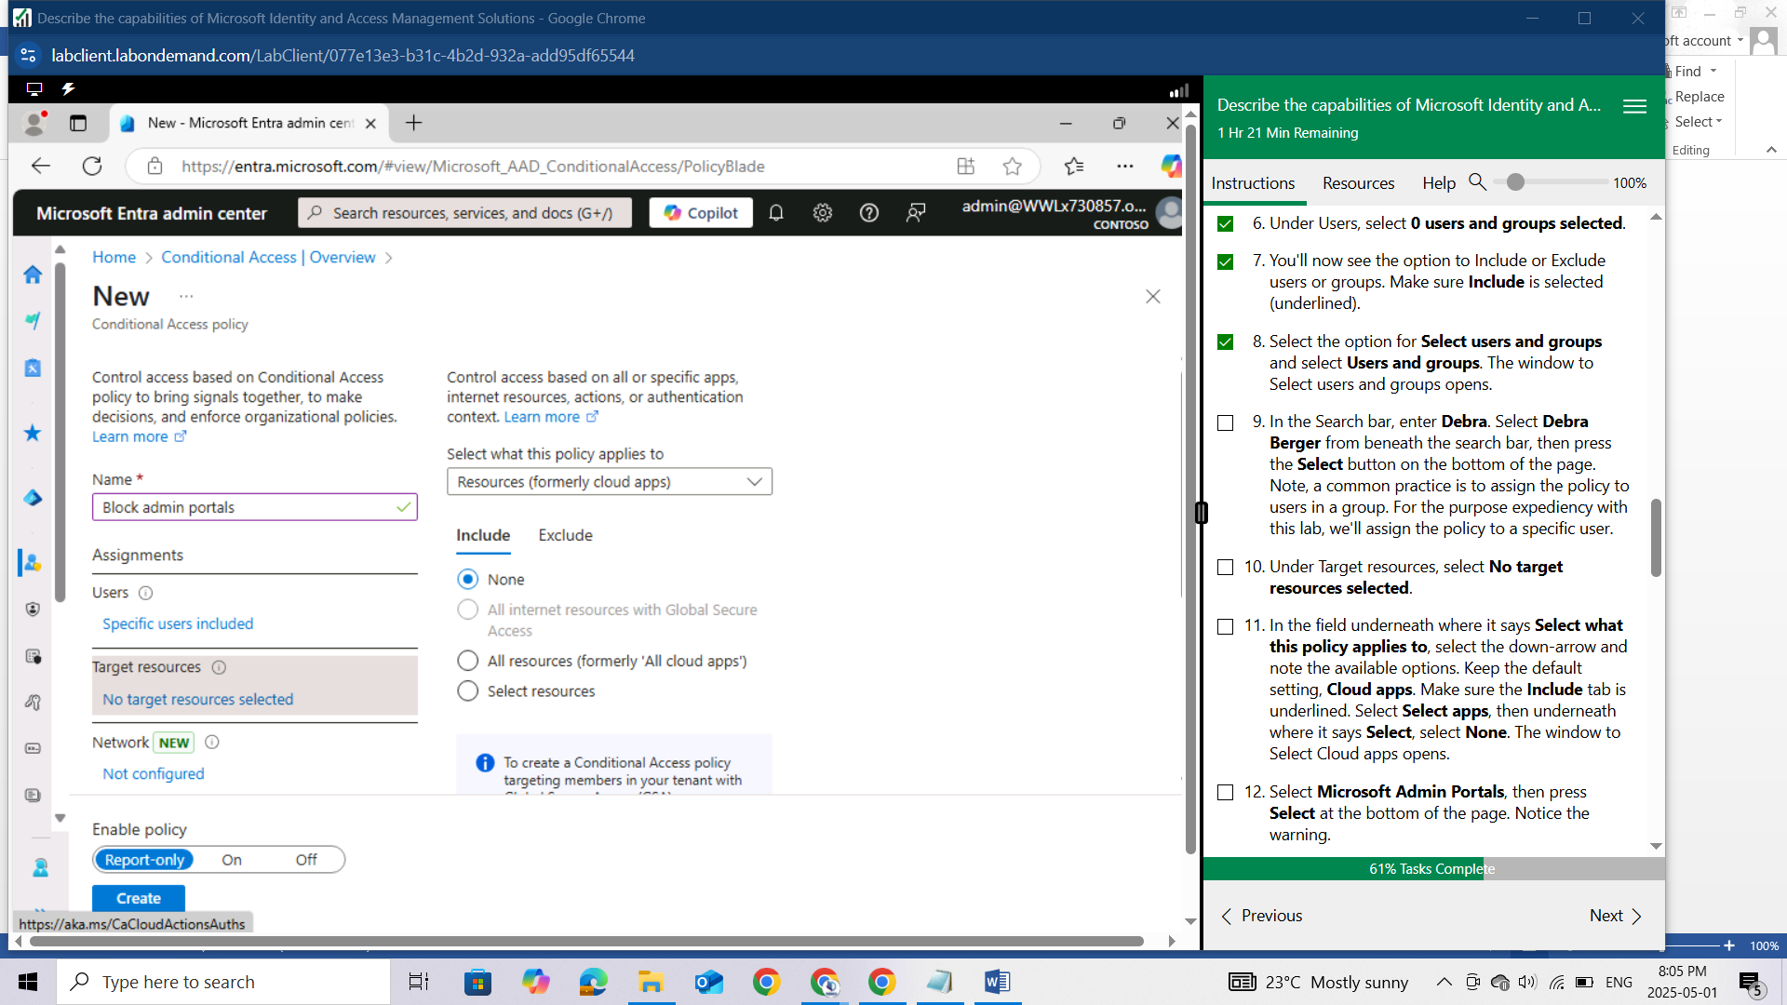

In the field underneath where it says Select what this policy applies to, select the down-arrow and note the available options. Keep the default setting, Cloud apps. Make sure the Include tab is underlined. Select Select apps, then underneath where it says Select, select None. The window to Select Cloud apps opens.

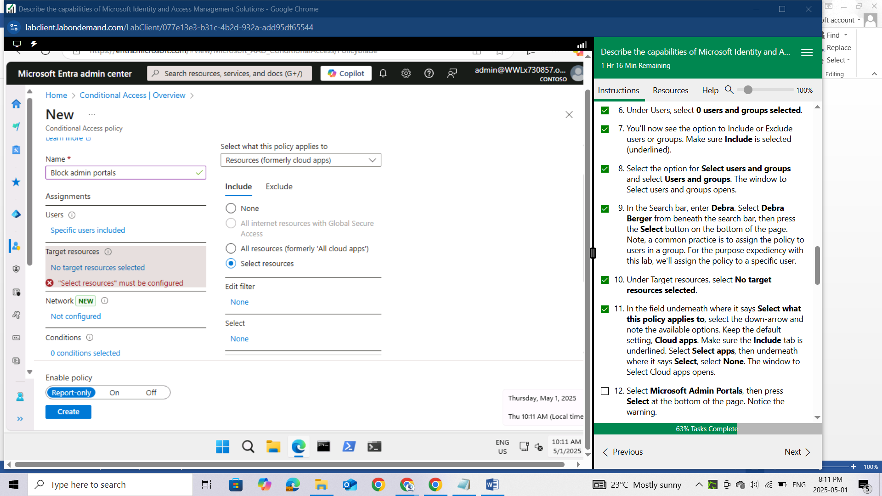

Select Microsoft Admin Portals, then press Select at the bottom of the page. Notice the warning.

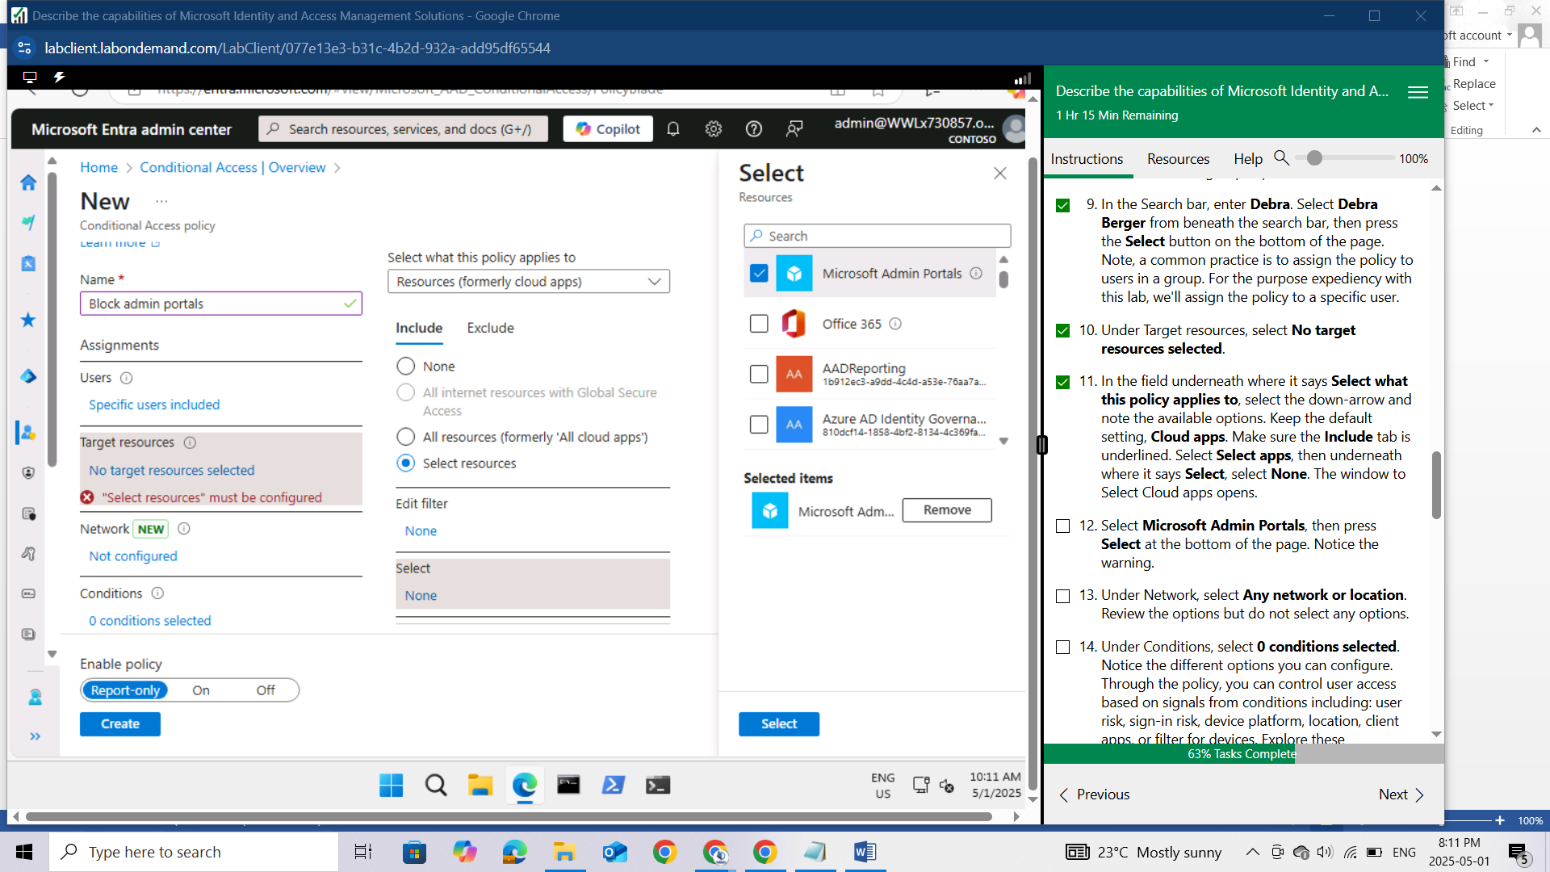

Under Network, select Any network or location. Review the options but do not select any options.

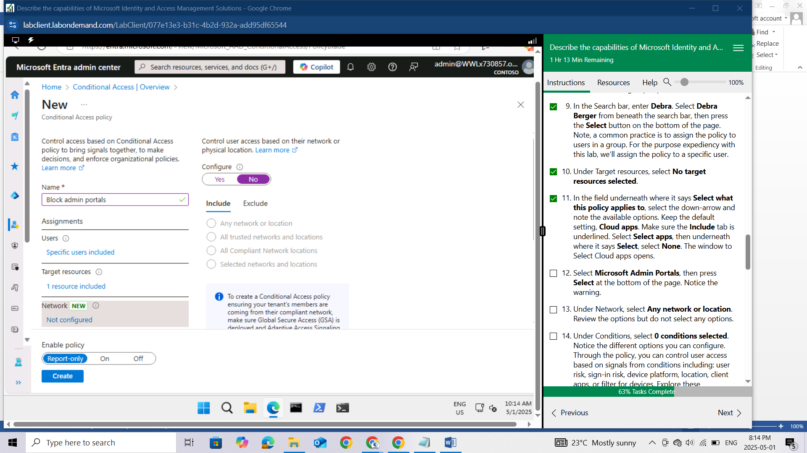

Under Conditions, select 0 conditions selected. Notice the different options you can configure. Through the policy, you can control user access based on signals from conditions including: user risk, sign-in risk, device platform, location, client apps, or filter for devices. Explore these configurable options, but do not set any conditions.

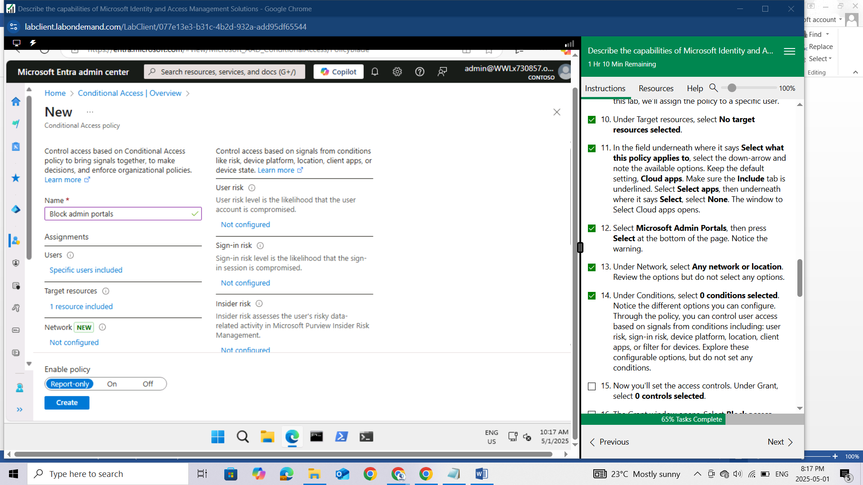

Now you'll set the access controls. Under Grant, select 0 controls selected

The Grant window opens. Select Block access. Press Select at the bottom of the page.

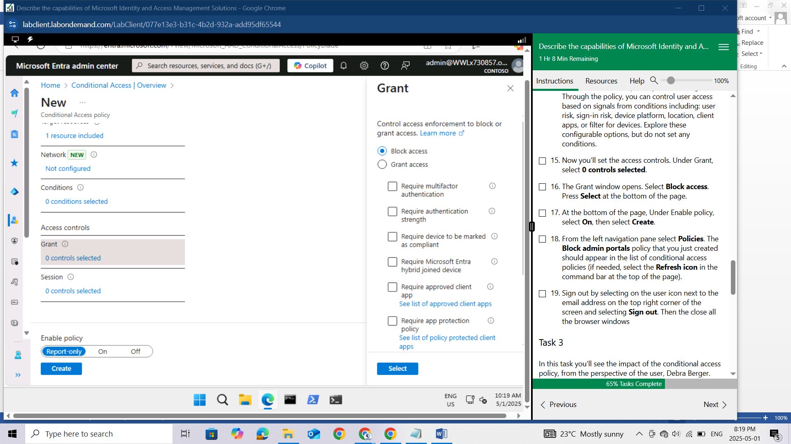

At the bottom of the page, Under Enable policy, select On, then select Create.

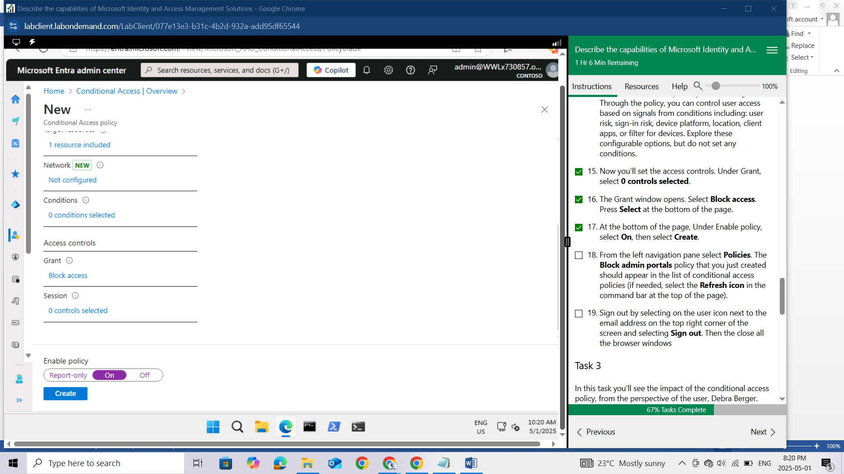

From the left navigation pane select Policies. The Block admin portals policy that you just created should appear in the list of conditional access policies (if needed, select the Refresh icon in the command bar at the top of the page).

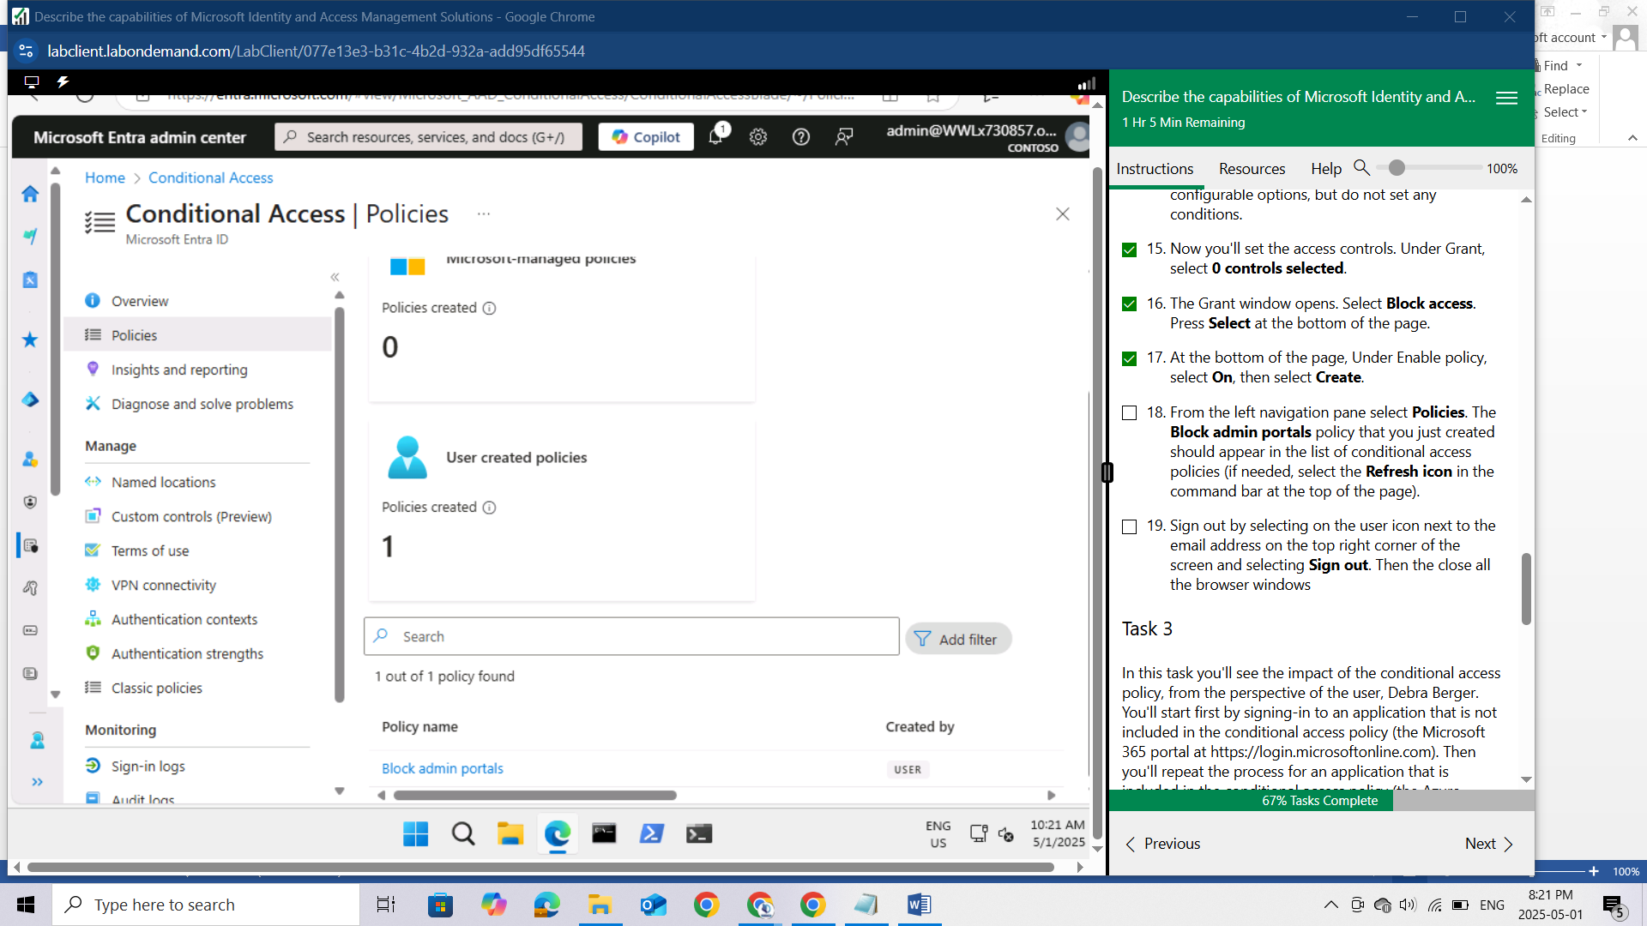

Sign out by selecting on the user icon next to the email address on the top right corner of the screen and selecting Sign out. Then the close all the browser windows

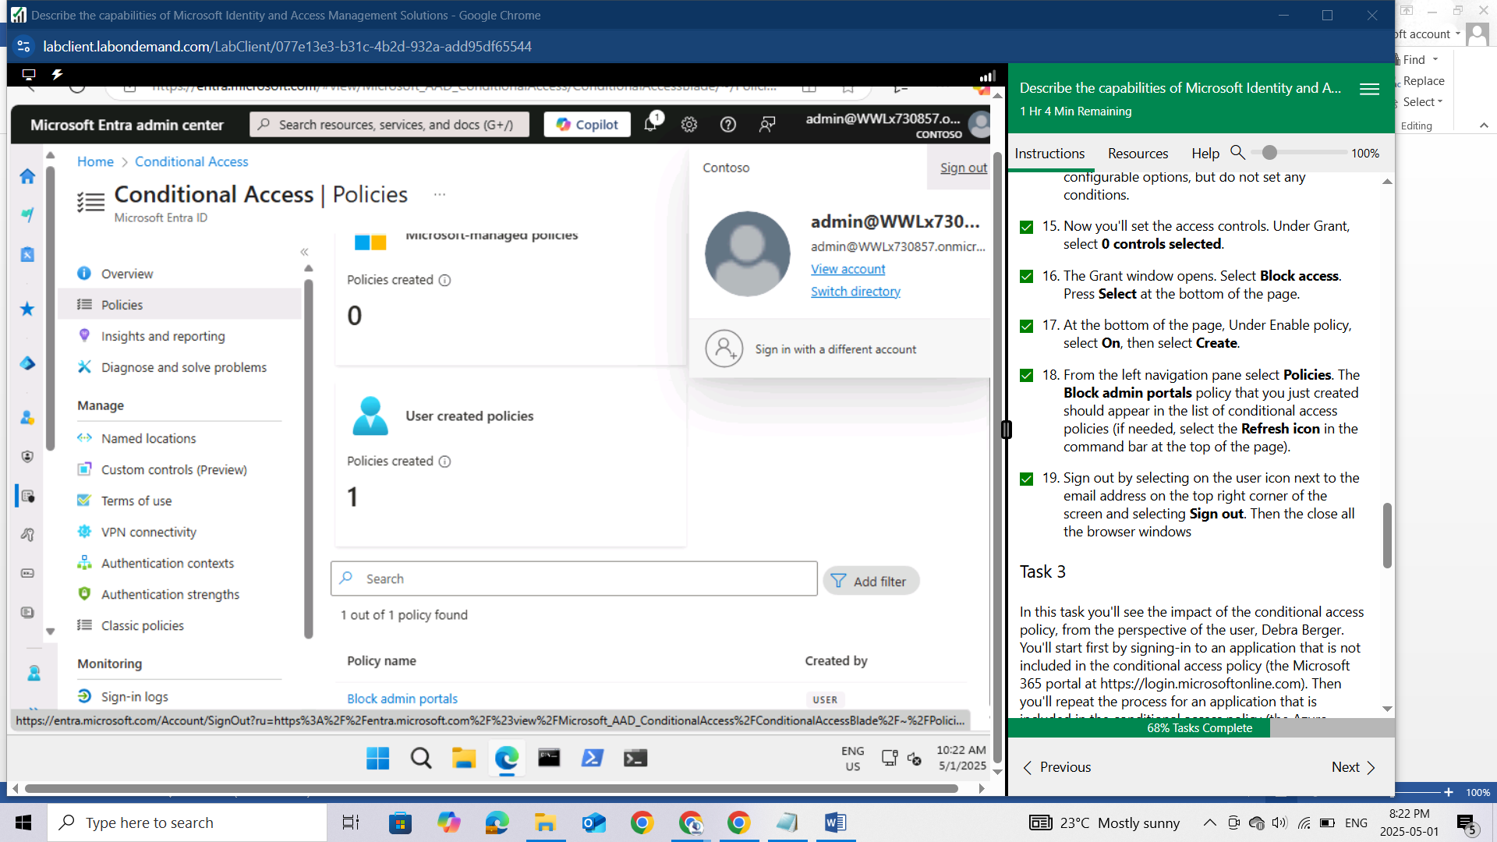

## Task 3

In this task you'll see the impact of the conditional access policy, from the perspective of the user, Debra Berger. You'll start first by signing-in to an application that is not included in the conditional access policy (the Microsoft 365 portal at https://login.microsoftonline.com). Then you'll repeat the process for an application that is included in the conditional access policy (the Azure portal at https://portal.azure.com). Recall that the policy blocks accessing any of the Microsoft Admin Portals, including the Azure portal. NOTE: For security reasons, all user accounts accessing any portal are required to use MFA. The MFA requirement is independent of this lab exercise.

Open Microsoft Edge. In the address bar, enter <https://login.microsoftonline.com>.

Sign in as DebraB@WWLx730857.onmicrosoft.com (where ZZZZZZ is your unique tenant ID provided by your lab hosting provider) then select Next.

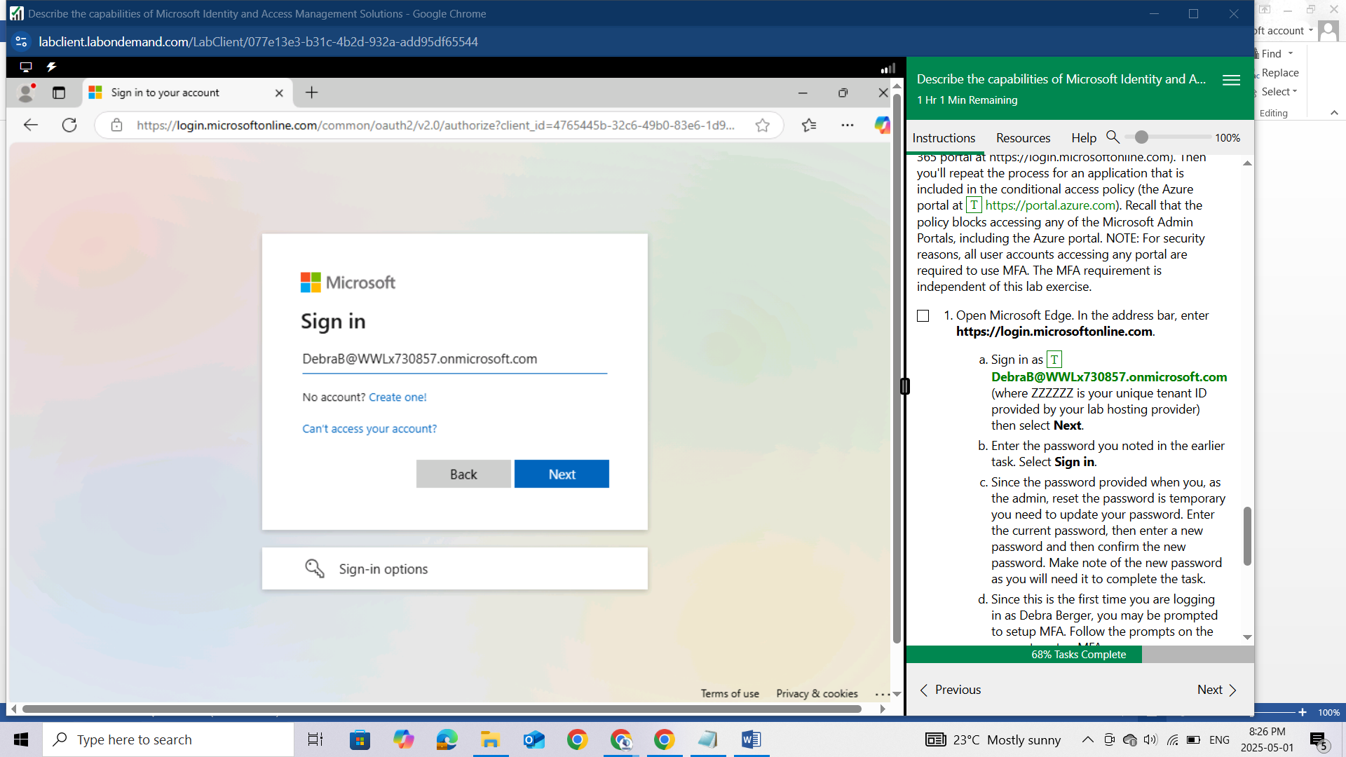

Enter the password you noted in the earlier task. Select Sign in.

Since the password provided when you, as the admin, reset the password is temporary you need to update your password. Enter the current password, then enter a new password and then confirm the new password. Make note of the new password as you will need it to complete the task.

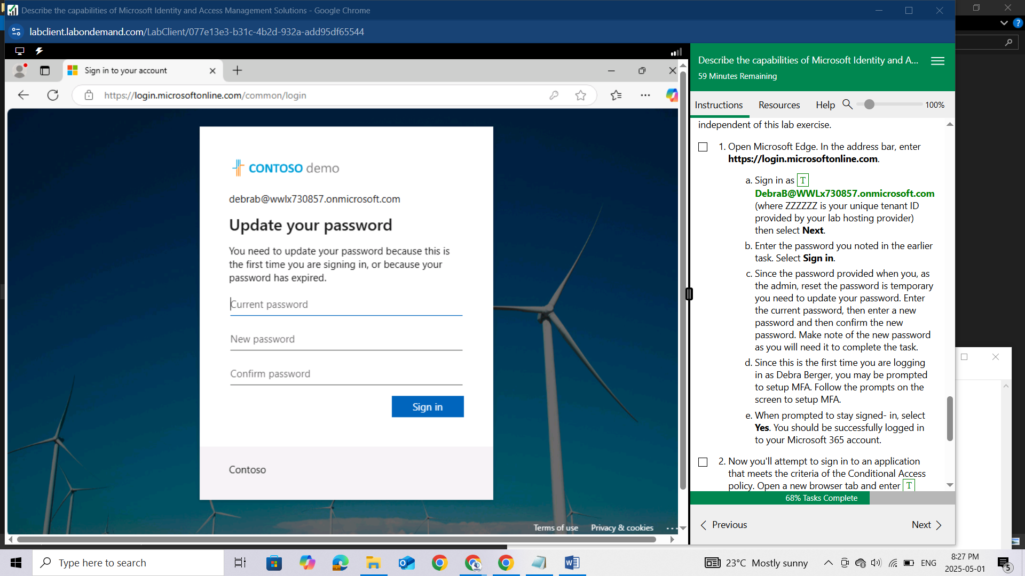

Since this is the first time you are logging in as Debra Berger, you may be prompted to setup MFA. Follow the prompts on the screen to setup MFA.

When prompted to stay signed- in, select Yes. You should be successfully logged in to your Microsoft 365 account.

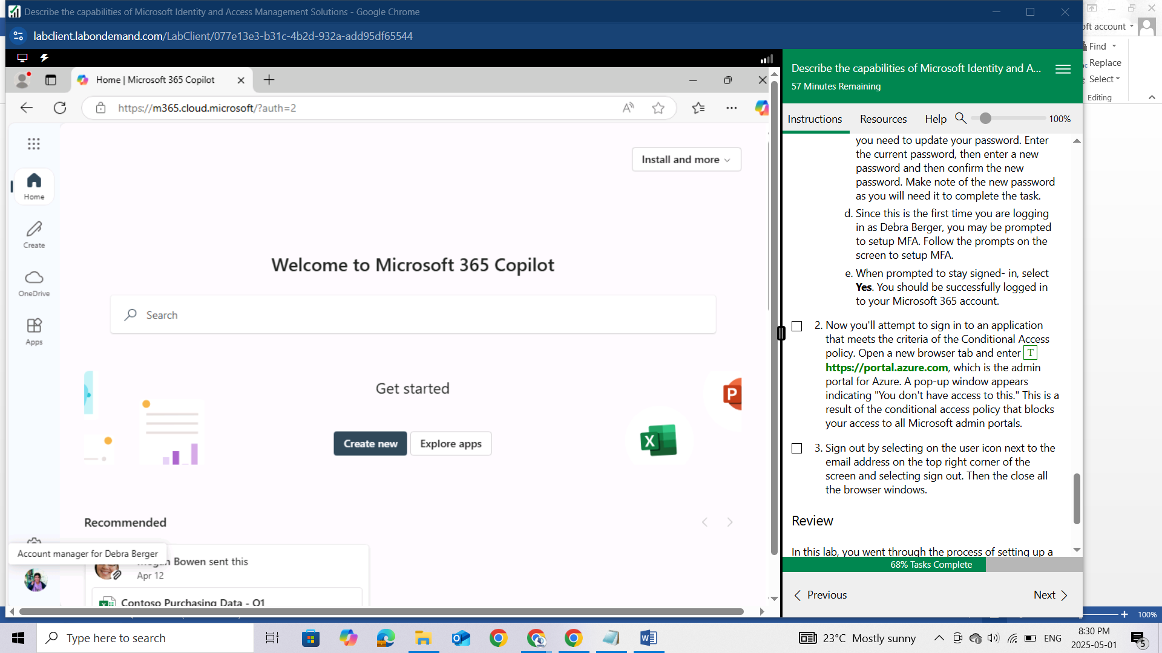

Now you'll attempt to sign in to an application that meets the criteria of the Conditional Access policy. Open a new browser tab and enter https://portal.azure.com, which is the admin portal for Azure. A pop-up window appears indicating "You don't have access to this." This is a result of the conditional access policy that blocks your access to all Microsoft admin portals.

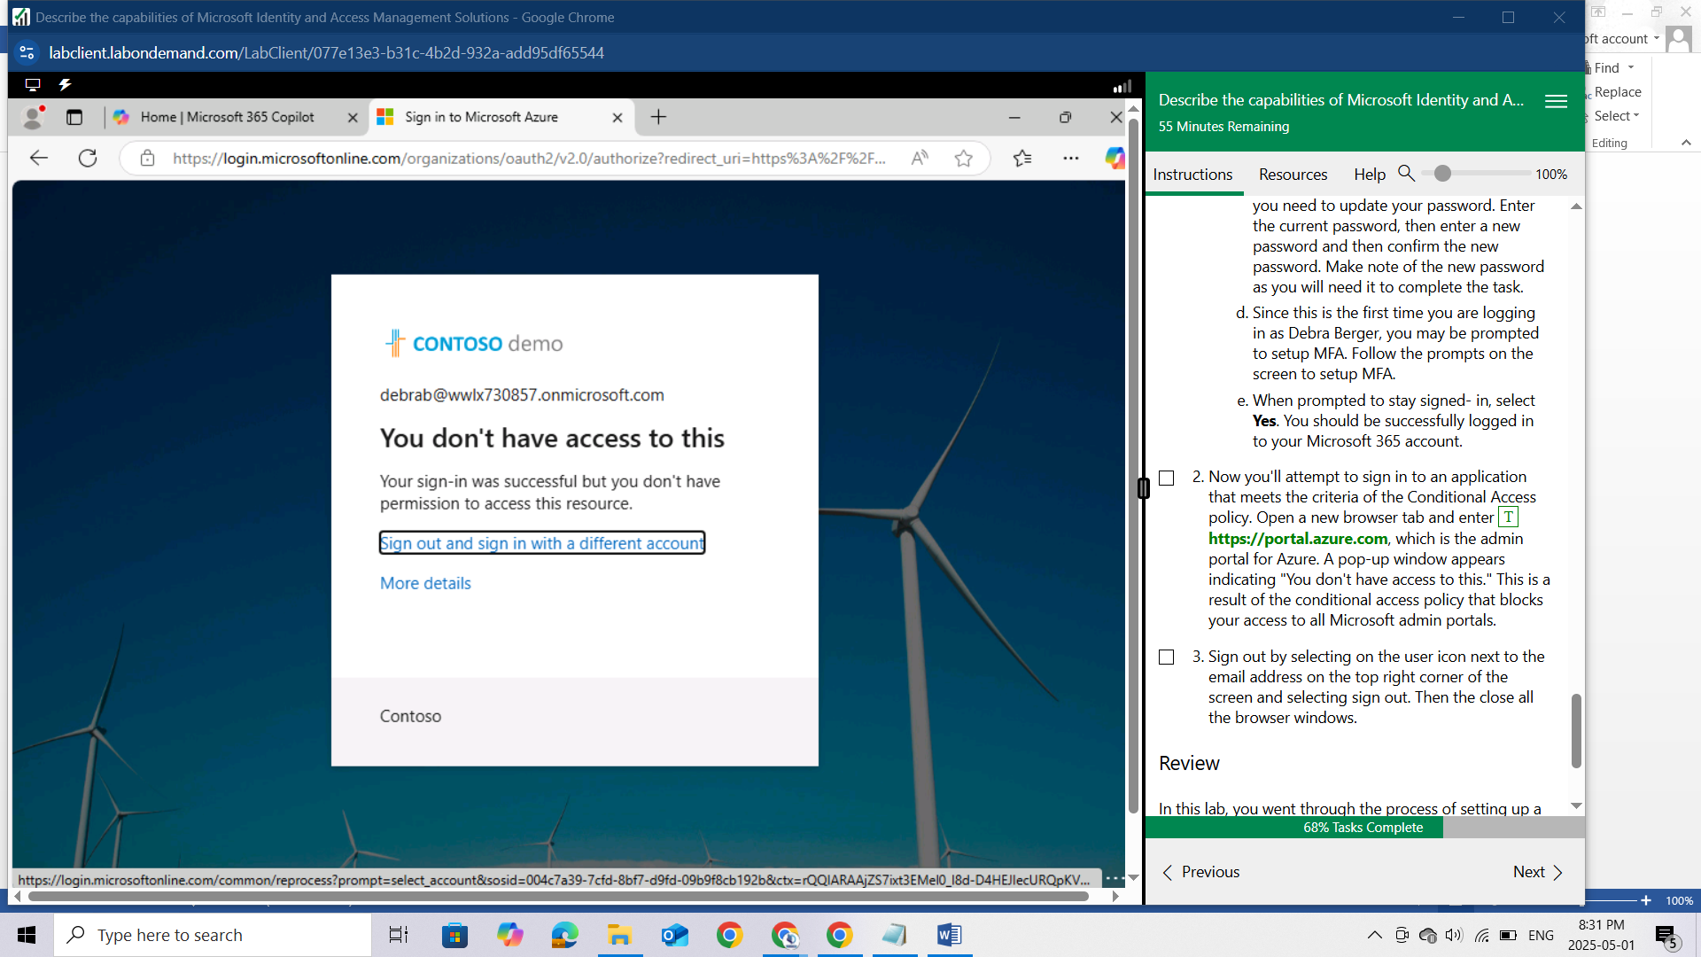

Sign out by selecting on the user icon next to the email address on the top right corner of the screen and selecting sign out. Then the close all the browser windows.

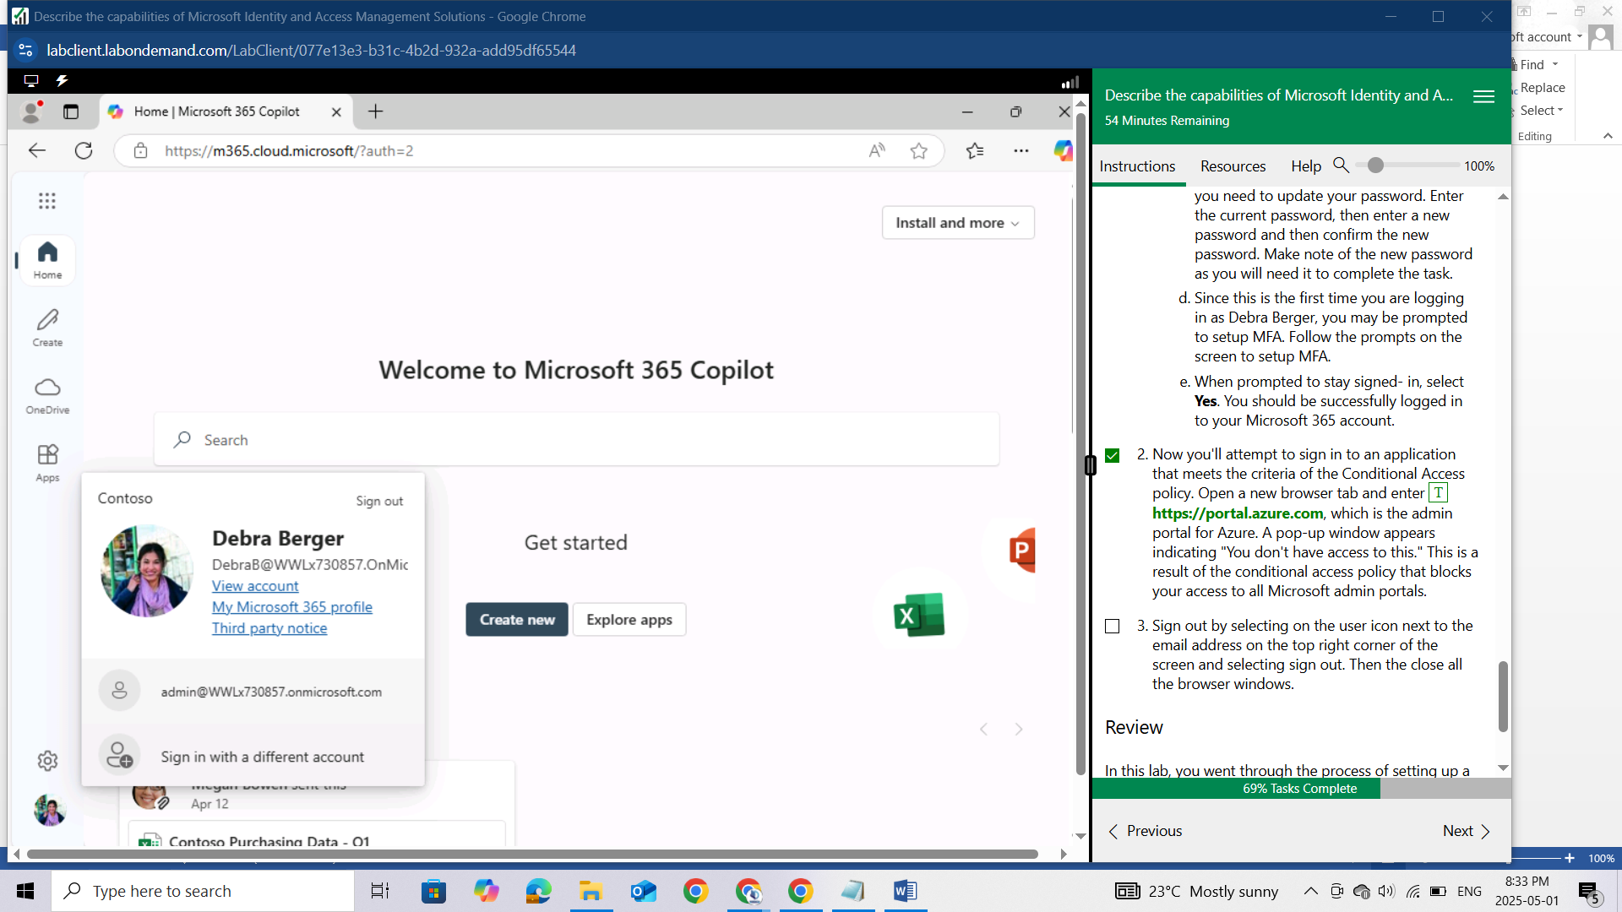

## Review

In this lab, you went through the process of setting up a conditional access policy that blocks access to Microsoft admin portals for all users included in the policy. Then, as a user you experienced the impact of the conditional access policy when accessing the Azure portal.